2014 CHAP HELP DAY

Christian Homeschool Association of Pennsylvania (CHAP)
Home Education Lobby Program (HELP)

Harrisburg Capitol Building - Main Rotunda
Wednesday, April 2, 2014 at 12:30 - 3:30 PM

Registration deadline: March 27, 2014

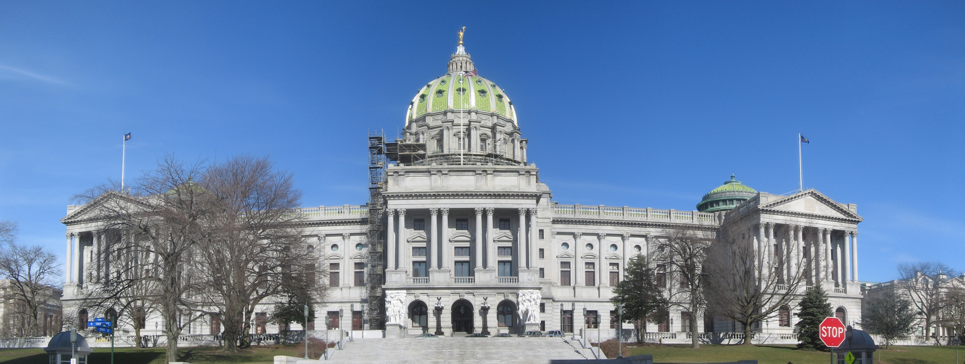

• Pro-actively advocate for better home education law and lobby for H.B. 1013

• Develop familiarity and show appreciation for our state legislators

• Allow public officials to meet a real homeschooling family

"The House Education Committee seemed very impressed by the strong turnout of homeschoolers for the hearing on House Bill 1013. They seemed very open to arguments
made in favor of the bill by the CHAP team."
~ Bruce Eagleson, Board Chairman, Christian Homeschool Association of Pennsylvania

On March 17, the House Education Committee held a hearing for House Bill 1013. So many homeschoolers turned out to show support that the room was filled and homeschoolers overflowed into and down the hallway! Testimonies were presented on the excellence of home education, the discriminatory result of our homeschool laws, and taxpayer savings homeschooling affords our public schools and the state. We will continue to petition our state legislature for more equitable laws.

CHAP HELP Day is a great opportunity for the whole family to participate. Even young children are invited if they are able to behave appropriately. We will be meeting with members of the House of Representatives urging them to support homeschooling. To honor these legislators for their public service, we will also bake them homemade pies, breads or cookies and provide them with information about homeschooling and House Bill 1013. To prepare your family for lobbying, read: Lobbying Tips for Families at CHAPonline.com before the event.

Check for Announcements and Updates at: http://www.CHAPonline.com
or Contact: CHAPHELPDay@chaponline.com

CHAP HELP DAY & BAKED GOODS SIGN UP

FINDING CHAP's TABLE AT THE CAPITOL: On Wednesday, April 2, 12:30 PM, CHAP will have tables set up around and near the main rotunda. It is best to come in the 3rd Street entrance because you come right into the main rotunda. You may also enter the building via the fountain entrance on Commonwealth Avenue and security officers can direct you from there; or just take the escalator up and walk straight down the hall. In front of you is the back of the famous staircase. Walk around it and you'll be at the main rotunda. Please arrive on time so you will have time to drop off your baked goods at the CHAP table, where you will be assigned a legislator, and pick up your family packets. [There might be another event going on until CHAP's meeting at 2:30 PM.] All participants are expected to read Lobbying Tips for Families before arrival and everybody is encouraged to visit a legislator (or more) between the hours of 12:30 PM to 2:00 PM. We will then gather at the rotunda for a 2:30 meeting with some homeschool leaders and legislators to talk about the next steps for House Bill 1013 and address questions you may have. We are blessed this year to have Dee Black himself join us from Home School Legal Defense Association.

PAMPHLETS & HANDOUTS: Each family will be provided with packets of information and assigned to visit a member of the House and/or Senate Education Committee. One packet will be for the legislator with some talking points and information about homeschooling data. There will also be a packet of educational materials for each family with a certificate of attendance for each participating homeschool student.

PIES, BREADS & COOKIES: Those who sign up to attend should bake something for two or three legislators. They must be home-made, not store bought. A few sugar-free and gluten-free baked goods would be appreciated for our legislators with dietary restrictions. All food must be clearly labeled with the ingredients or full recipe, along with your name, address or phone number and legislative district. Attach this underneath. Please bake pies in a disposable tin and place them inside a gallon-size storage or freezer bag. Cookies can be nicely arranged on a disposable plate or tray wrapped in clear plastic wrap, and the same for the breads.

We really need everybody to bring baked goods but if you absolutely cannot, please help cover the cost of Legislative Day expenses with a donation of $20 per family. Please write out your checks to CHAP and bring it along or mail to: Christian Homeschool Association of Pennsylvania at 231 N. Chestnut St., Palmyra PA 17078.

PROTOCOLS: We will be guests in a professional office building conducting the official business of our state. Noise and activity must be kept to a minimum. Because the intent of Legislative Day is to make the most effective presentation possible and to facilitate conversation with our legislators, young children must be closely supervised. Out of respect for our officials and to leave a good impression, dress your best.
- - - - - - - - - - - - - - - - - - - - - - - - - - - - - - -

CHAP HELP Day 2014 Sign-up

Your Name: __________________________________________________ Phone: ______________________

Number of children attending Lobby Program _________ Their ages: _________________________________

Address: ___________________________________________ E-mail: _______________________________

_________________________________________________ Zip Code: _______________________

Number of Pies: _____ Bread: _____ Plate of Cookies: _____
Number of Special Diet Items: 100% Gluten Free_____ Sugar Free_____

_____ I will be unable to bring baked goods but will contribute $20 for Legislative Day.

Print and use this form to hand out to others.
Please email the above information to: CHAPHELPDay@chaponline.com

Registration deadline: March 27, 2014

